**EXPERIMENT 6**

Write the python program for Vacuum Cleaner problem.

**AIM:**

The aim is to solve the vacuum cleaner problem using python program.

**PROGRAM:**

class VacuumCleaner:

def __init__(self):

self.location = 0

self.environment = ['Dirty', 'Dirty']

def sense(self):

return self.environment[self.location]

def clean(self):

self.environment[self.location] = 'Clean'

def move(self):

if self.location == 0:

print("Moving to location B")

self.location = 1

else:

print("Moving to location A")

self.location = 0

def run(self):

print("Starting vacuum cleaner...")

for _ in range(2):

dirt_condition = self.sense()

if dirt_condition == 'Dirty':

print("Cleaning dirt...")

self.clean()

print("Moving to next location...")

self.move()

print("Cleaning complete!")

if __name__ == "__main__":

vacuum = VacuumCleaner()

vacuum.run()

**INPUT:**

Dirty

Clean

Move to next location.

**OUTPUT:**

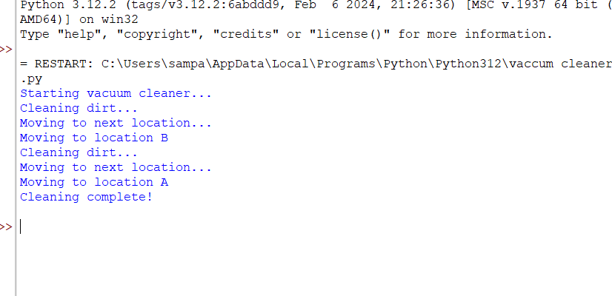

**RESULT:**

The vacuum cleaner is executed successfully.